PRACTICAL 9

Q1 Write a Program to use all the function of Introspection.

<?php

echo "20438 UMME ATIYA<br><hr>";

class a{

public function func(){

echo" I am class A";

}

}

class b extends a{

public function func(){

echo" I am ".get_class($this). "class<br><br>";

echo" I am ".get_parent_class($this). "class<br><br>";

}

}

if(class_exists("a")){

$obj=new a();

echo "The class name is :".get_class($obj)."<br><br>";

$obj->func();

}

if(class_exists("b")){

$obj1=new b();

$obj1->func();

if(is_subclass_of($obj1,"a")){

echo "The class :".get_class($obj1)."is subclass of ".get_parent_class($obj1)."<br><br>";

}

if(is_subclass_of($obj1,"a")){

echo "The class :".get_class($obj1)."is subclass ";

}

}

?>

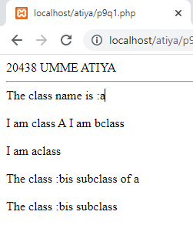

Q2 Write a Program to use the function of Serialization.

<?php

echo "20438 UMME ATIYA<br><hr>";

$str=array(" Betty"," had"," a"," bitter"," butter!");

echo "Array before serialize:";

print_r($str);

$s=serialize($str);

echo"<br><br>String after serialize:".$s."";

?>

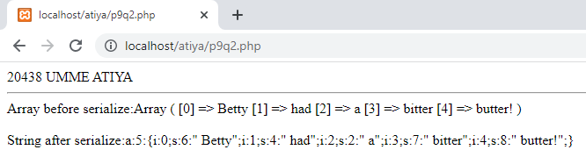

PRACTICAL 10

Q1 Write a Program for designing a Webpage using Textbox, Radio button, Checkbox and Buttons and display all the data that is entered by user.

HTML:

<html>

<body>

<form action="p10q1.php" method="get">

Enter Name: <input type="text" name="name"/><br><br>

Select Gender: <br><input type="radio" name="gender" value="male">Male<br><input type="radio" name="gender" value="female">Female<br><br>

Select Hobbies: <br><input type="checkbox" name="c1" value="Programming">Programming<br>

<input type="checkbox" name="c2" value="Travelling">Travelling<br>

<input type="checkbox" name="c3" value="Reading">Reading<br>

<input type="checkbox" name="c4" value="Cooking">Cooking<br>

<input type="checkbox" name="c5" value="Singing">Singing<br><br>

<input type="submit" value="submit">

<input type="reset" value="reset">

</form>

</body>

</html>

PHP:

<?php

echo "20438 UMME ATIYA<br><hr>";

$name=$_GET["name"];

$gender=$_GET["gender"];

echo "Your Name: ".$name;

echo "<br>Your Gender: ".$gender;

if(isset($_GET["c2"])){

echo "<br>Your Hobbie: ".$_GET["c2"];

}

if(isset($_GET["c3"])){

echo "<br>Your Hobbie: ".$_GET["c3"];

}

if(isset($_GET["c4"])){

echo "<br>Your Hobbie: ".$_GET["c4"];

}

if(isset($_GET["c5"])){

echo "<br>Your Hobbie: ".$_GET["c5"];

}

if(isset($_GET["c1"])){

echo "<br>Your Hobbie: ".$_GET["c1"];

}

?>

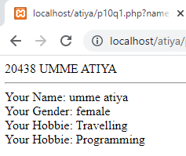

PRACTICAL 8

Q1 Write a Program for Array of Objects.

<?php

class c{

function construct(){

echo "hello<br>";

}

}

echo "20438 UMME ATIYA<br><hr>";

$o1=new c();

$o2=new c();

$o3=new c();

$o4=new c();

$a =array($o1,$o2,$o3,$o4);

print_r($a);

?>

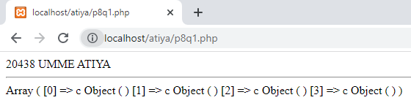

Q2 Write a Program for Method Overloading.

<?php

class c{

function __call($name,$args){

if($name=="area"){

switch(count($args)){

case 1: return 3.14*$args[0];

case 2: return $args[0]*$args[1];

}

}

elseif($name=="perim"){

switch(count($args)){

case 1: return 4*$args[0];

case 2: return 2*($args[0]+$args[1]);

}

}

}

}

echo "20438 UMME ATIYA<br><hr>";

$obj = new c();

echo "<br>Area of square: ".$obj->area(13);

echo "<br>Perimeter of rect: ".$obj->perim(10,20)

?>

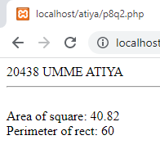

Q3 Write a Program for Method Overriding.

<?php

class c{

function func(){

echo "hello this is PARENT class 1<br>";

}

}

class c2 extends c{

function func(){

echo "hello this is CHILD class 2<br>";

}

}

echo "20438 UMME ATIYA<br><hr>";

$obj1=new c();

$obj2=new c2();

$obj1->func();

$obj2->func();

?>

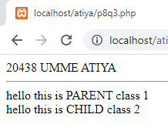

Q4 Write a Program for Single level Inheritance.

<?php

class c1{

public $name;

public $roll;

function func($n,$r){

$this->name=$n;

$this->roll=$r;

}

function disp() {

echo "<br>Name: ".$this->name;

echo "<br>Roll No : ".$this->roll;

}

}

class c2 extends c1{

function __construct(){

echo "<br>Accessing elements of Parent class";

}

}

echo "20438 UMME ATIYA<br><hr>";

$obj1=new c2();

$obj1->func("Umme Atiya","20438");

$obj1->disp();

?>

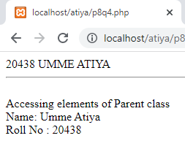

Q5 . Write a Program for Multi-level Inheritance.

<?php

class c{

function func1(){

echo "hello this is class 1<br>";

}

}

class c2 extends c{

function func2(){

echo "hello this is class 2<br>";

}

}

class c3 extends c2{

function func3(){

echo "hello this is class 3<br>";

}

}

echo "20438 UMME ATIYA<br><hr>";

$obj1=new c3();

$obj1->func1();

$obj1->func2();

$obj1->func3();

?>

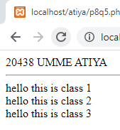

Q6 Write a Program for Multiple Inheritance. (make use of Trait)

<?php

class c{

function func1(){

echo "hello this is class 1<br>";

}

}

trait c2{

function func2(){

echo "hello this is class 2<br>";

}

}

class c3 extends c{

use c2;

function func3(){

echo "hello this is class 3<br>";

}

}

echo "20438 UMME ATIYA<br><hr>";

$obj1=new c3();

$obj1->func1();

$obj1->func2();

$obj1->func3();

?>

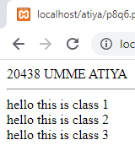

Q7 . Write a Program for Hierarchical Inheritance.

<?php

class c{

function func1(){

echo "hello this is class 1<br>";

}

}

interface c2{

}

class c3 extends c implements c2{

function func3(){

echo "hello this is class 3<br>";

}

function func2(){

echo "hello this is class 2<br>";

}

}

echo "20438 UMME ATIYA<br><hr>";

$obj1=new c3();

$obj1->func1();

$obj1->func2();

$obj1->func3();

?>

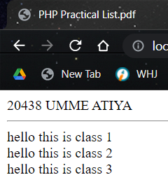

8. Write a Program for Constructor and Destructor.

<?php

echo "20438 UMME ATIYA<br><hr>";

class exp8

{

public $test;

function __construct($m)

{

echo "Constructor is called...<br>";

$this->test = $m;

}

function __destruct()

{

echo "Destructor is called...<br>";

}

function showval()

{

echo "Value of variable set with constructor is " . $this->test . "<br>";

}

}

$obj = new exp8("UMME");

$obj->showval();

?>

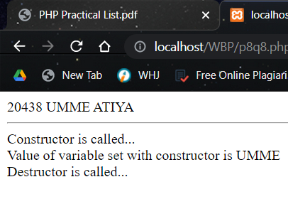

9. Write a Program for Abstract class.

<?php

echo "20438 UMME ATIYA<br><hr>";

abstract class abs_class

{

public $n1, $n2;

public abstract function calculate();

}

class full extends abs_class

{

function __construct($a, $b)

{

$this->n1 = $a;

$this->n2 = $b;

}

public function calculate()

{

return $this->n1 + $this->n2;

}

}

$obj = new full(12, 13);

echo "Addition of " . $obj->n1 . " and " . $obj->n2 . " is " . $obj->calculate()

?>

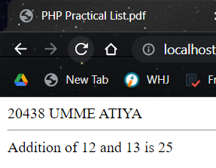

10. Write a Program for Final keyword with respective to class.

<?php

final class A

{

public function show()

{

echo "final class";

}

}

class B extends A

{

public function show()

{

echo "cannot inherited final class";

}

}

$obj = new B();

$obj->show();

?>

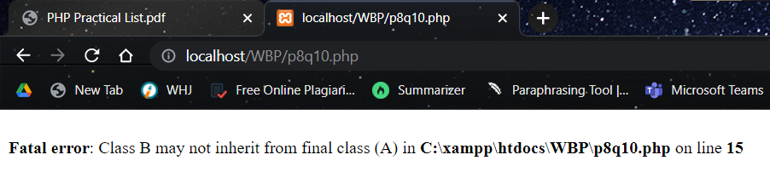

11. Write a Program for Final keyword with respective to function.

<?php

class A

{

final public function show()

{

echo "This function is declared as final";

}

}

class B extends A

{

final public function show()

{

echo "final function";

}

}

$obj = new B();

$obj->show();

?>

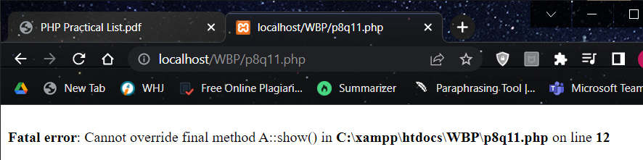

12. Write a Program for static keyword with respective to variable.

<?php

echo "20438 UMME ATIYA<br><hr>";

class A

{

public static $name;

public function display()

{

self::$name = "umme";

echo "Static variable used within same class: " . self::$name;

}

}

class B extends A

{

public function disp()

{

parent::$name = "atiya";

echo "<br>Static variable used in chlid class class: " . parent::$name;

}

}

$obj = new B;

$obj->display();

$obj->disp();

B::$name = "20438";

echo "<br >Static variable used inside body: " . B::$name;

?>

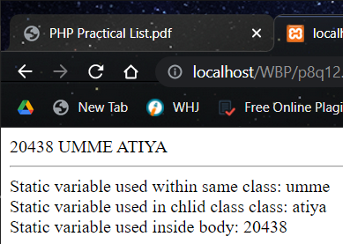

13. Write a Program for static keyword with respective to function and properties.

<?php

echo "20438 UMME ATIYA<br><hr>";

class maths

{

public static function add($a, $b)

{

return $a + $b;

}

public function display()

{

echo "adding 5 and 10 in the same class: " . self::add(5, 10);

}

}

class science extends maths

{

public function dis()

{

echo "<br>adding 2 and 6 in the child class: " . parent::add(2, 6);

}

}

$obj = new science;

$obj->display();

$obj->dis();

echo "<br>adding 3 and 2 inside the main body: " . science::add(3, 2);

?>

